Case Setup
Ultrasound Preparation:
- Ensure phased array, linear, and curvilinear probes are present, functioning and clean.
- Ensure the ultrasound screen is easily visible to the examinee, either directly or via screen share.

When Examinee Enters:
“Hello Doctor, I am Dr. _ and will be assisting as your examiner for this ultrasound case. As a reminder, please ask me to change probes, change depth, gain, or mode of ultrasound to assist you with the case. Please ask for help to reposition the patient or bed. Do you have any questions?”

Case vignette:
“As you have noted, the patient is presenting with shortness of breath.”

For diagnostic ultrasound:
“I would like for you to now demonstrate how you would assess the patient’s shortness of breath using ultrasound to evaluate the lung base / diaphragmatic junction. Which probe would you like to use?”
Probe settings:
- Linear
  - Gain 10, depth 5cm
- Phased array
  - Gain 10, depth 15cm
- Curvilinear
  - Gain 10, depth 15cm
If asked to change probe settings:
- “Tell me when to stop adjusting [gain/depth]
  - Adjust the gain and depth slowly, allowing the examinee to stop you.

“When you find an acceptable image, please let me know.”

After examinee has selected their image, using their own clip/image:
“Thank you, I will take the probe from you now. Please direct your attention to the screen. Please point out any artifacts, anatomy, or pathology that would be important for this complaint.”

Then show the examinee the pathology clip/image:
“Now assume this image/clip is the image obtained of this patient. Please point out any pathology you see on this image/clip.”

Application:
“What would your immediate next steps be for this patient?”
-Refer to the grading criteria if using it as an educational case.

End of case:
“Thank you, that concludes your case.”

Case Pearls & Pitfalls:
- When initially finding the lung base / diaphragmatic junction you may want to position the probe similar to a RUQ/LUQ FAST exam view, and then slide cranially to visualize the lung (the PLAPS view: Posterior/lateral alveolar pleural syndrome). This is the most sensitive view for pleural effusions.
- In patients with significant symptoms, you may need to scan the patient sitting up or at a 45 degree angle because the patient may be unable to lay flat on their back due to their dyspnea.
- Sometimes the diaphragm can act as a strong reflective surface and appear to mirror the liver into the lung space. This is known as the mirror artifact and is a sign of healthy lung tissue (a pleural effusion would prevent this finding):

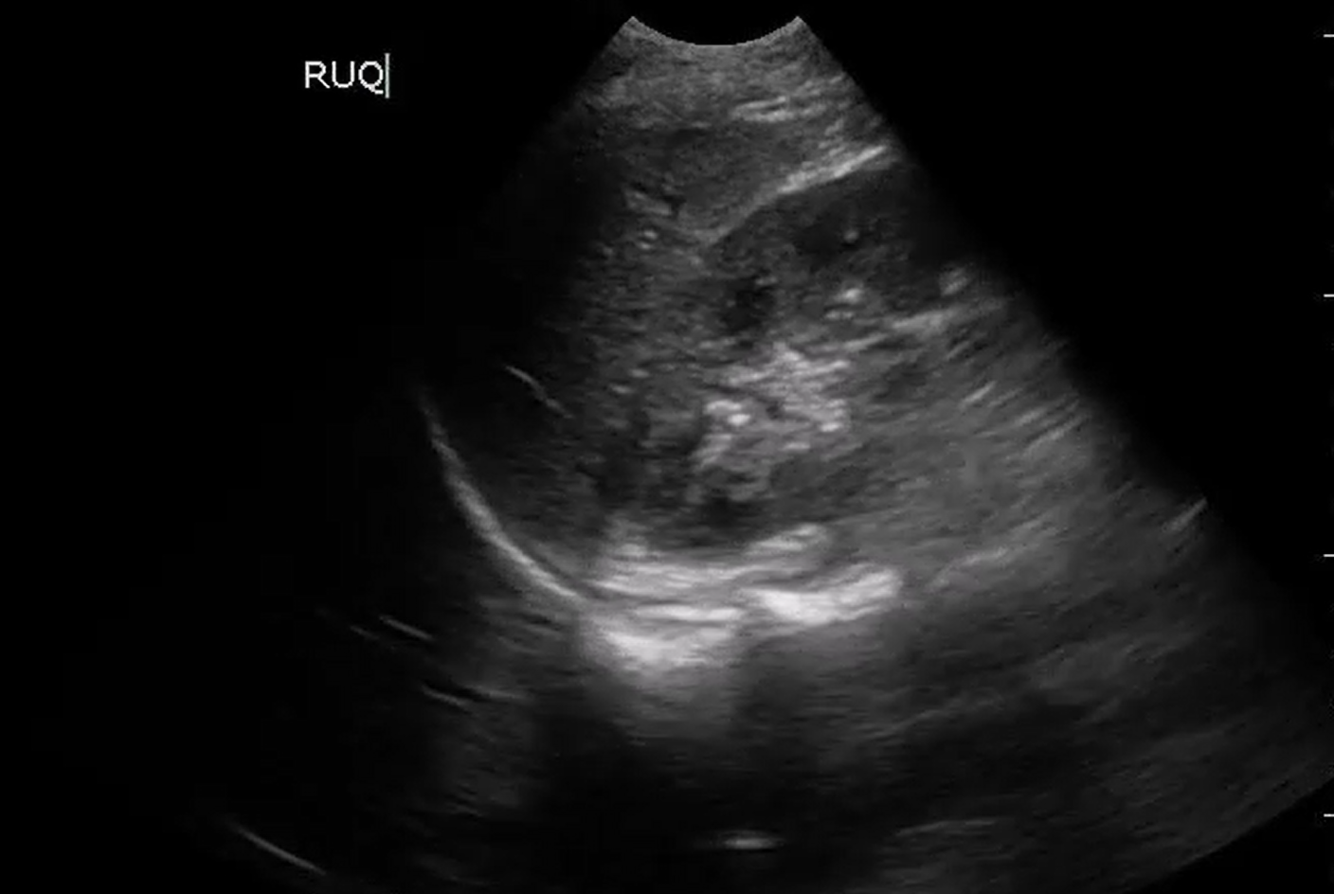
Mirror artifact reflecting the liver into the bottom left of the image.

